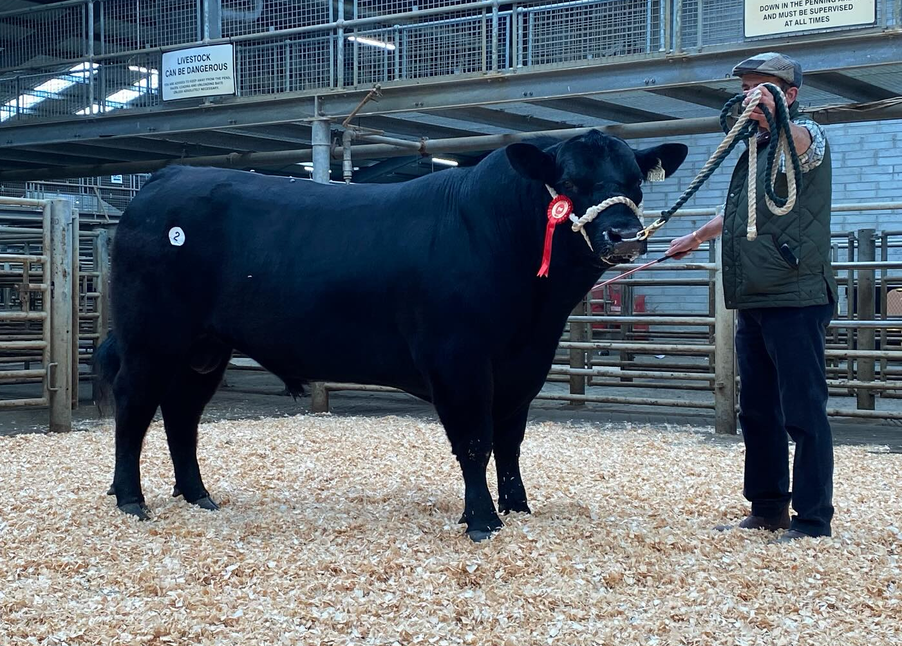
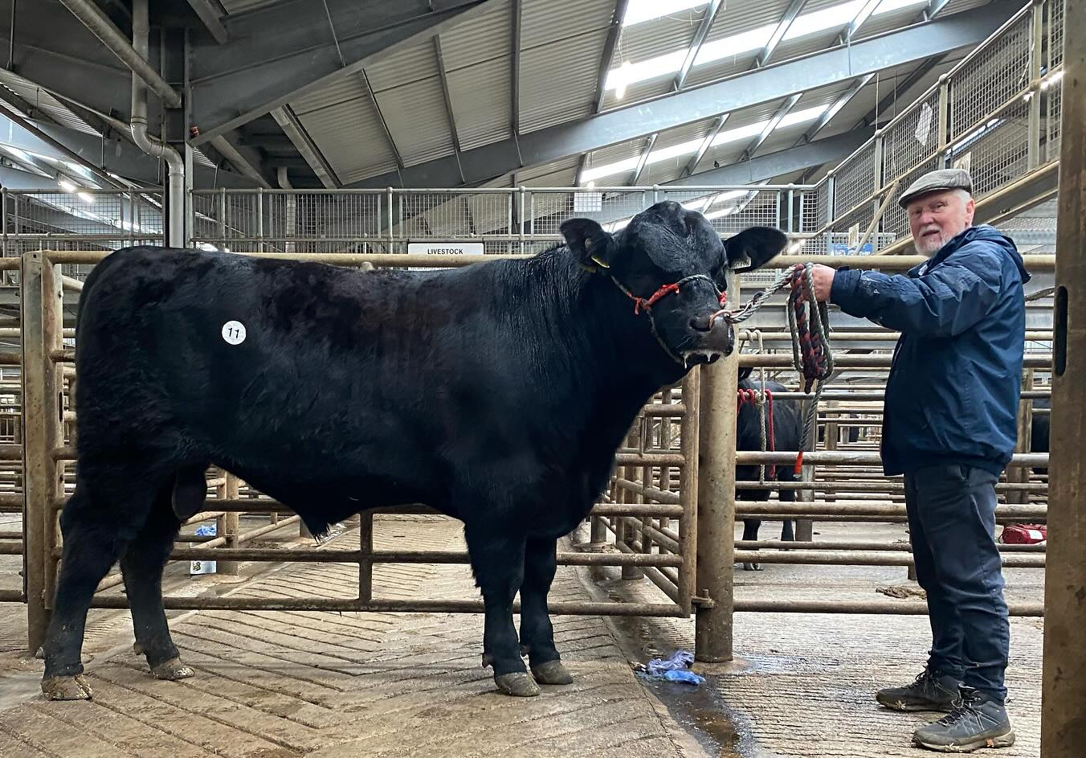
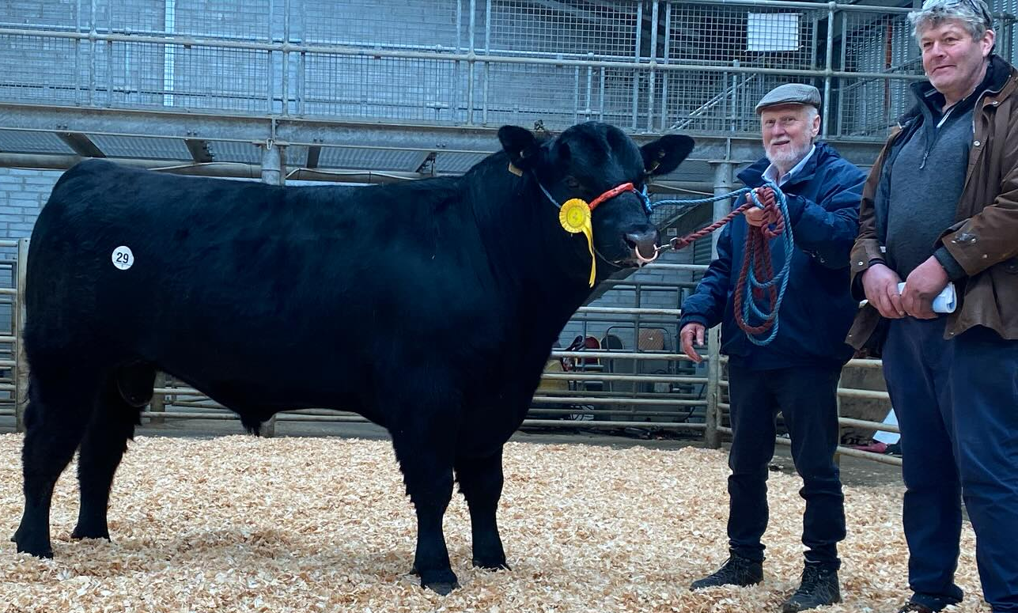
Ballykeevican Windy Sold €5,500 Bred by: Luke Maye, Rockingham, Boyle, Co. Roscommon

Clooncolligan Wonderful Sold: €6,100 Bred by: Kevin & Monica Diffley, Clooncolligan, Bornacoola, Co. Leitrim

Clooncolligan Winter Sold: €6,300 Bred by: Kevin & Monica Diffley, Clooncolligan, Bornacoola, Co. Leitrim

